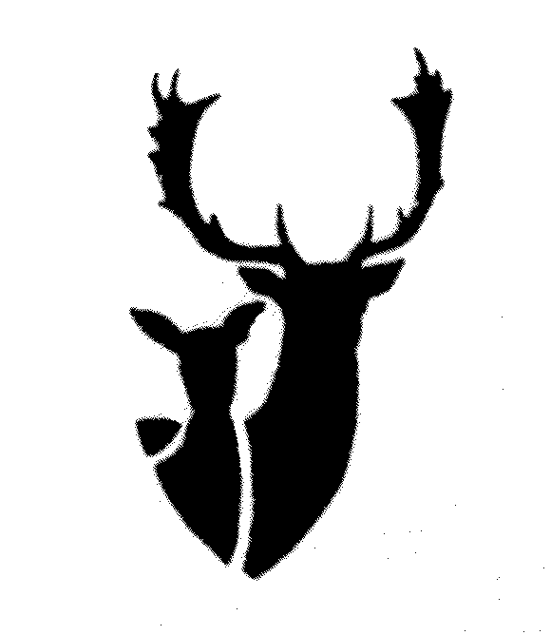Tasmanian Deer Advisory Committee Inc.

To The Secretary,

The TDAC would like to propose amendments to the wildlife general regulation prior to a draft signed off by your office.
Affixing tags.
- Metal license tags, can be removed from antler at a licensed Taxidermist and fixed to the base of a mounted trophy.
Tags rust and degrade over time and it would not pose any issues if this is done at the point of being mounted.

Regards Andrew Winwood
Chairperson TDAC Inc.
Mob. 0413999279
andrew.winwood06@gmail.com

Tasmanian Deer Advisory Committee Inc.

To The Secretary,

Old

47. Prohibition on organised shoot without permission

(1) Except with the written permission of the Secretary, a person must not –

(a) arrange or provide facilities for an organised shoot; or
(b) while carrying a firearm, take part in an organised shoot.

Penalty: Fine not exceeding 100 penalty units

Minor changes have been made to this in Draft Regs only change relates to PPP, this entire reg should be removed as per previously discussed at TDAC and Game council meetings.

It is outdated and the organized shoot no long takes place.

PBGMP hunting groups could be unfairly disadvantaged under this Regulation.

Regards Andrew Winwood
Chairperson TDAC Inc.
Mob. 0413999279
andrew.winwood06@gmail.com

Tasmanian Deer Advisory Committee Inc.

To The Secretary,

The TDAC would like to propose amendments to the Nature Conservation (wildlife) regulation prior to a draft signed off by your office.
Crop Protection Permits proposed change to: Property Protection Permit, TDAC would support this as a positive change; we would also recommend the following to be added.
Inclusion.
- Make it illegal for taxidermist to mount trophies shot with a PPP.
PPP ( CPP ) were not designed for the taking of trophy animals, but were issued ONLY for crop protection.
- Make it illegal to remove the antlers from the property for all male deer harvested on PPP .
- Or Tag between trez and brow then cut antlers off above trez before transporting.
We strongly believe these conditions are required to eliminate a loophole used by some shooters to harvest trophy bucks in the weeks leading up to an open hunting season.
CPP were issued for a purpose crop protection NOT for trophy harvest, this loophole needs to be closed so that the new Property Protection Permits are not exploited by a few.
The TDAC have received an increasing number of calls from concerned hunters that have witnessed shooters that are using CPP tags to harvest trophy male deer on the eve of the Male hunting season.This was confirmed with a visit to a well-known taxidermist.
This also supports the current Governments commitment with regards to QDM..

Regards Andrew Winwood
Chairperson TDAC Inc.
Mob. 0413999279
andrew.winwood06@gmail.com

Tasmanian Deer Advisory Committee Inc.

To The Secretary,

The TDAC would like to propose amendments to the Nature Conservation (wildlife) regulation prior to a draft signed off by your office.
Reg 71 - using a detection device - clarification on items and when or when not can they be used.

To just list detection device is not acceptable and is open for interpretation.

For example:
- Trail Camera
- Thermal monocular

These items are legal now and the changes to the regs could be interpreted that these items or a security system would also be illegal on a property within the Deer core range.

A spot light and firearm can assist in the hunt, a trail camera can only detect and then does not assist in the hunt of an animal.

Regards Andrew Winwood
Chairperson TDAC Inc.
Mob. 0413999279
andrew.winwood06@gmail.com

Tasmanian Deer Advisory Committee Inc.

To The Secretary,

The TDAC would require further consultation in relation to this proposed change it is perceived that a person of a higher position than a department employee would assume responsibilities originally preserved for the secretary.

The TDAC ask that the original wording does not require any change.
This statement implies an employee could make changes without senior approval.

Commercial Purposes Licence:

The Draft Regulations establish a Commercial Purposes Licence which is an amalgamation of several current licences to simplify commercial wildlife related activities. An applicant for a Commercial Purposes Licence would be able to apply for a single licence to possess and sell multiple species of wildlife which presently require multiple applications and authorisations (Note that take of species occurs primarily under property protection permits).
The addition of ‘protected’ wildlife to the types of wildlife that may be traded would clarify that those wildlife currently taken under permits may be traded commercially with the Secretary’s approval.

Under the proposed changes, the Department would have flexibility to allow selected species of protected wildlife to be bought and sold, where appropriate.
Change from Secretary to department.

Regards Andrew Winwood
Chairperson TDAC Inc.
Mob. 0413999279
andrew.winwood06@gmail.com

Tasmanian Deer Advisory Committee Inc.

To The Secretary,

To The Secretary,

Property Protection Permit.

(2) The Holder of a property protection Permit may also do one or more of the following, as specified on the permit:
(a) to possess the products of wildlife taken in accordance with subregulation (1):

(b) to dispose of such products of Wildlife.

The TDAC believes the below exclusion should be included to list:

Deer as unable to be traded under a PPP.

Regards Andrew Winwood
Chairperson TDAC Inc.
Mob. 0413999279
andrew.winwood06@gmail.com

