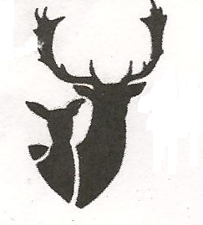

Email andrew.winwood06@gmail.com

The Hon Rebecca White MP
Leader of the Opposition in Tasmania

Dear Ms White,
I am writing to request a meeting between yourself and the TDAC to discuss topics including deer and browsing wildlife in Tasmania. I would welcome the attendance of other members of your party, who may have shadow portfolios relating to this sphere of management.
The TDAC has worked for many years with governments, both Labor and Liberal for the structured management of deer. Traditional hunters are an important element of the Tasmanian rural landscape. Hunting and game control provides widespread economic activity, significant volunteer assistance to the rural community and meaningful mental welfare benefits by providing access for hunters and families to an outdoors life style.
Our member groups have had considerable input in shaping the improvement to our hunting seasons in Tasmania; we will continue to work harmoniously to improve Deer Management in our state.
Topics for discussion that are currently hotly debated and of interest to us and many voters would include, the future status of wild fallow deer, the potential commercial harvest of wild fallow deer and the ongoing management of wildlife in our state.
We are open to meet in a location that is suitable to you and your party members.
I look forward to meeting you and discussing these topics with you.

Your sincerely

Andrew Winwood
President
TDAC

